IT5512- WEB TECHNOLOGY LAB-SESSION-1
DATE: 13/09/2021 FN
NAME: A.S. PRUTHIEV
REG NO.2019506067
ARRAY AND LIST JAVA PROGRAMS

1) AIM:
To write a Array and List Java code for the calculation of student details like adding a student, search a student with his/her name,Find the student with maximum cgpa , Find the student with minimum cgpa,Sort the student by name,Sort the student by cgpa.
.
1) a
AIM:
To Write a java program to perform various operations in student class using List interface in Collection library.

ALGORITHM:

- Create a class Student with private fields like name,cgpa,age,roll number
- Create a constructor which accepts and intializes the above field varaibles
- Use getter methods for each fields to return them as they are declared as private
- Overload the toString method to get out own desired way of displaying
- In the main method,Create a ArrayList and allocate memory
- Create a menu driven program in which
- Choice 1 → Add Student
- Choice 2 → Remove Student by name
- Choice 3 → Search Student by name
- Choice 4 → Find Student with maximum cgpa
- Choice 5 → Find Student with minimum cgpa
- Choice 6 → Sort the student list by name
- Choice 7 → Sort eh student list by cgpa
- Choice 8 → Display the student details

- For every Choice creat a method and implement the logic
- The implementation of above methods are done by the inbuitl List methods and methods in Collections class and stream features
- This process goes untill the choice given by the user is negative which will make the program to stop.

PROGRAM CODE:

package Java.Lab.lab2;
import java.util.*;
class Student{
private String name,rollNumber;
int curSem,age;
double cgpa;
public Student(String name, String rollNumber, int curSem, int age, double cgpa) {
this.name = name;
this.rollNumber = rollNumber;
this.curSem = curSem;
this.age = age;
this.cgpa = cgpa;
}
public String getName() {
return name;
}
public String getRollNumber() {
return rollNumber;
}
public int getCurSem() {
return curSem;
}
public int getAge() {
return age;
}
public boolean isNull(){
return false;
}
public double getCgpa() {
return cgpa;
}
@Override
public String toString() {
return name + " " + rollNumber + " " + age + " " + cgpa + " " + curSem;
}
}
public class ListArray {
private static Scanner input = new Scanner(System.in);
public static void add(ArrayList<Student>students){
int age,curSem;
String name,rollNumber;
double cgpa;
input.nextLine();
System.out.print("Enter name :");
name = input.nextLine();
System.out.print("Enter roll number :");
rollNumber = input.nextLine();
System.out.print("Enter age , current Semester, and cgpa :");
age = input.nextInt();
curSem = input.nextInt();
cgpa = input.nextDouble();
students.add(new Student(name,rollNumber,curSem,age,cgpa));
}
public static void remove(ArrayList<Student>students){
input.nextLine();
String name;
System.out.print("Enter student name :");
name = input.nextLine();
if(students.removeIf(x -> x.getName().equals(name)))System.out.println("Student name removed successfully");
else System.out.println("Student name not exists");
}
public static void search(ArrayList<Student>students){
input.nextLine();
String name;
System.out.print("Enter student name :");
name = input.nextLine();
if((students.stream().filter(x -> x.getName().equals(name)).findAny().orElse(null) != null)){
System.out.println("Student exists");
}
else System.out.println("Student details not exists");
}
public static Student findMaxCGPA(ArrayList<Student>students){
double maxCgpa = students.stream().mapToDouble(Student::getCgpa).max().orElse(-1);
return students.stream().filter(x -> x.getCgpa() == maxCgpa).findAny().orElse(null);
}
public static Student findMinCGPA(ArrayList<Student>students){
double maxCgpa = students.stream().mapToDouble(Student::getCgpa).min().orElse(-1);
return students.stream().filter(x -> x.getCgpa() == maxCgpa).findAny().orElse(null);
}
public static void sortByName(ArrayList<Student>students){
students.sort(Comparator.comparing(Student::getName));
}
public static void sortByCGPA(ArrayList<Student>students){
students.sort(Comparator.comparing(Student :: getCgpa).reversed());
}
public static void main(String[] args) {
ArrayList<Student>students = new ArrayList<>();
int choice;
System.out.println("The choice are :");
System.out.println("1 --> Add Student\n2 --> Remove Student\n3 --> Search a Student\n4 --> Find Student with max CGPA" +
"\n5 --> Find Student with min CGPA\n6 --> Sort Students by name\n7 --> Sort students by CGPA\n8 --> Display Details\n");
do {
System.out.print("Enter the choice :");
choice = input.nextInt();
switch (choice) {
case 1 -> add(students);
case 2 -> remove(students);
case 3 -> search(students);
case 4 -> {
Student st = findMaxCGPA(students);
if (st != null) {
System.out.println(st);
}
}
case 5 -> {
Student st1 = findMinCGPA(students);
if (st1 != null) {
System.out.println(st1);
}
}
case 6 -> {
sortByName(students);
System.out.println(students);
}
case 7 -> {
sortByCGPA(students);
System.out.println(students);
}
case 8 -> {
System.out.println(students);
}
default -> System.out.println("Enter a valid choice !!!");
}
}while(choice >= 0);
}
}

OUTPUT:

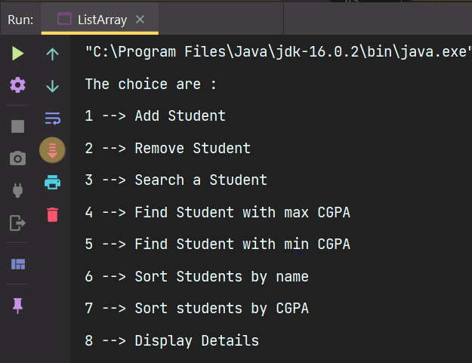
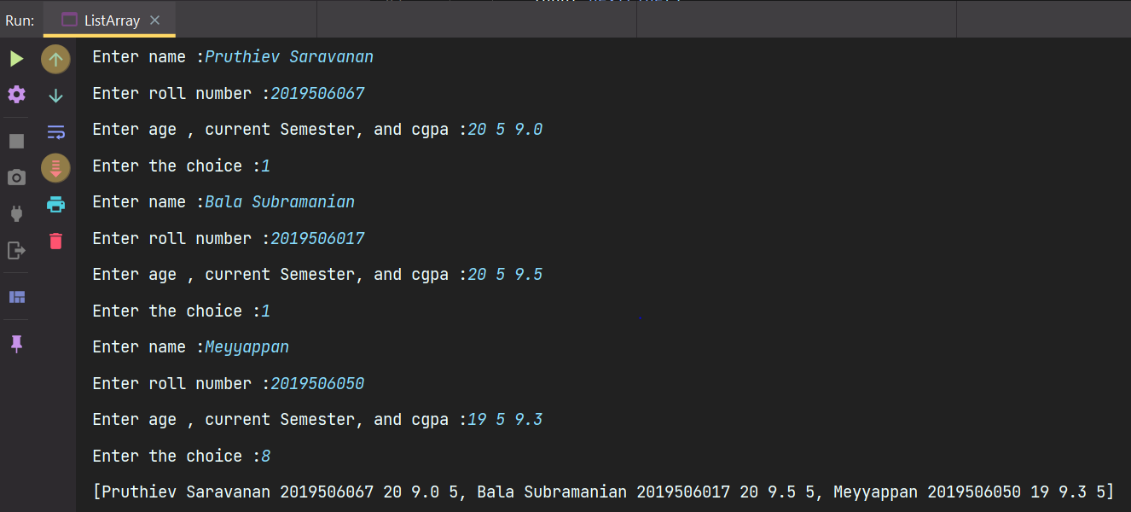
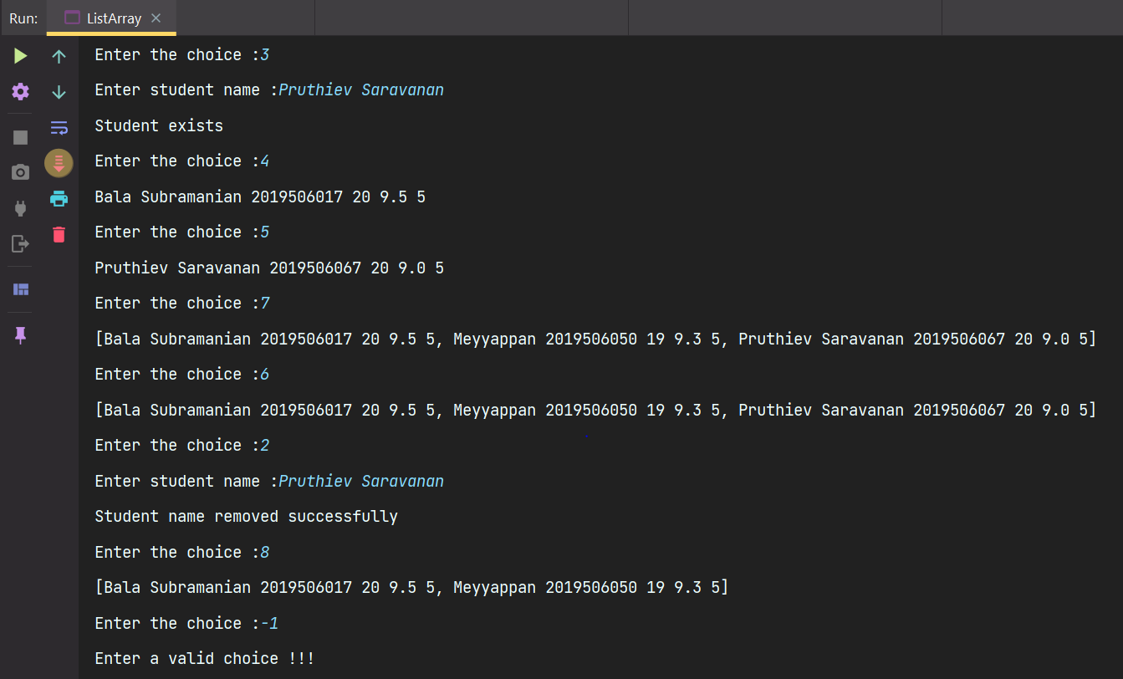

RESULT:
Thus, the program has been executed successfully.

1) b.
AIM:
To Write a java program perform various operations in student class using Array data type

ALGORITHM:

- Enter the number of students as in case of array and read it in n
- In the main method,Create a Student Array[] and allocate the size as n.
- Create a menu driven program in which
- Choice 1 → Add Student
- Choice 2 → Remove Student by name
- Choice 3 → Search Student by name
- Choice 4 → Find Student with maximum cgpa
- Choice 5 → Find Student with minimum cgpa
- Choice 6 → Sort the student list by name
- Choice 7 → Sort eh student list by cgpa
- Choice 8 → Display the student details

- For every Choice creat a method and implement the logic
- These methods are implemeted by the in built methods available in Arrays class and stream features.
- This process goes untill the choice given by the user is negative which will make the program to stop.

PROGRAM CODE

package Java.Lab.lab2;

import java.util.*;

public class Array {
private static Scanner input = new Scanner(System.in);
static int count = 0;
public static void add(Student[]students){
int age,curSem;
String name,rollNumber;
double cgpa;
input.nextLine();
System.out.print("Enter name :");
name = input.nextLine();
System.out.print("Enter roll number :");
rollNumber = input.nextLine();
System.out.print("Enter age , current Semester, and cgpa :");
age = input.nextInt();
curSem = input.nextInt();
cgpa = input.nextDouble();
if(count >= students.length)System.out.println("Array is full ");
else students[count++] = new Student(name,rollNumber,curSem,age,cgpa);
}
public static void remove(Student[]students){
input.nextLine();
String name;
System.out.print("Enter student name :");
name = input.nextLine();
int index = -1;
for(int i = 0 ; i < students.length ; i++){
if(students[i].getName().equals(name)){
index = i;
break;
}
}
if(index != -1){
for(int i = index ; i < students.length-1 ; i++){
students[i] = students[i+1];
}
students[count-1] = null;
count --;
System.out.println("The student details are removed successfully");
}
else{
System.out.println("Student does not exists");
}

}
public static void search(Student[]students){
input.nextLine();
String name;
System.out.print("Enter student name :");
name = input.nextLine();
Student findStudent = Arrays.stream(students).filter(x -> (x.getName().equals(name))).findAny().orElse(null);
if(findStudent != null)System.out.println("The student detail exists");
else System.out.println("The student details does not exists");
}
public static Student findMaxCGPA(Student[]students){
return Arrays.stream(students).max(Comparator.comparing(Student :: getCgpa)).orElse(null);
}
public static Student findMinCGPA(Student[]students){
return Arrays.stream(students).min(Comparator.comparing(Student :: getCgpa)).orElse(null);
}
public static void sortByName(Student[]students){
Arrays.sort(students,Comparator.nullsLast(Comparator.comparing(Student ::getName)));
}
public static void sortByCGPA(Student[]students){
Arrays.sort(students,Comparator.nullsLast(Comparator.comparing(Student ::getCgpa).reversed()));
}
public static void main(String[] args) {
int n;
System.out.println("Enter the number of students :");
n = input.nextInt();
Student[]students = new Student[n];
int choice;
System.out.println("The choice are :");
System.out.println("1 --> Add Student\n2 --> Remove Student\n3 --> Search a Student\n4 --> Find Student with max CGPA" +
"\n5 --> Find Student with min CGPA\n6 --> Sort Students by name\n7 --> Sort students by CGPA\n8 --> Display Details\n");
do {
System.out.print("Enter the choice :");
choice = input.nextInt();
switch (choice) {
case 1 -> add(students);
case 2 -> remove(students);
case 3 -> search(students);
case 4 -> {
Student st = findMaxCGPA(students);
if (st != null) {
System.out.println(st.toString());
}
}
case 5 -> {
Student st1 = findMinCGPA(students);
if (st1 != null) {
System.out.println(st1.toString());
}
}
case 6 -> {
sortByName(students);
Arrays.stream(students).filter(Objects::nonNull).forEach((x) -> System.out.print(x.toString() + " , "));
System.out.println();
}
case 7 -> {
sortByCGPA(students);
Arrays.stream(students).filter(Objects::nonNull).forEach((x) -> System.out.print (x.toString() + " , "));
System.out.println();
}
case 8 -> {
Arrays.stream(students).filter(Objects::nonNull).forEach((x) -> System.out.print(x.toString() + " , "));
System.out.println();
}
default -> System.out.println("Enter a valid choice !!!");
}
}while(choice >= 0);
}

}

OUTPUT:

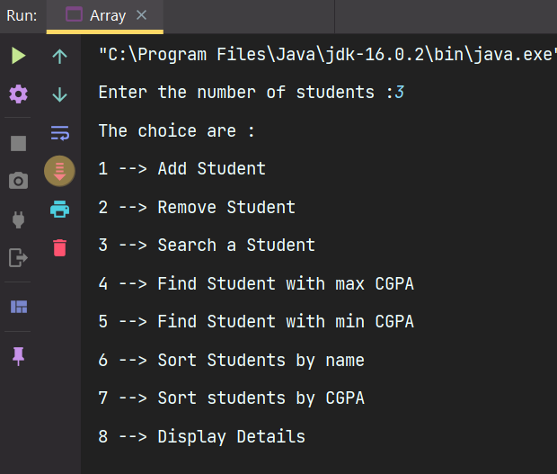

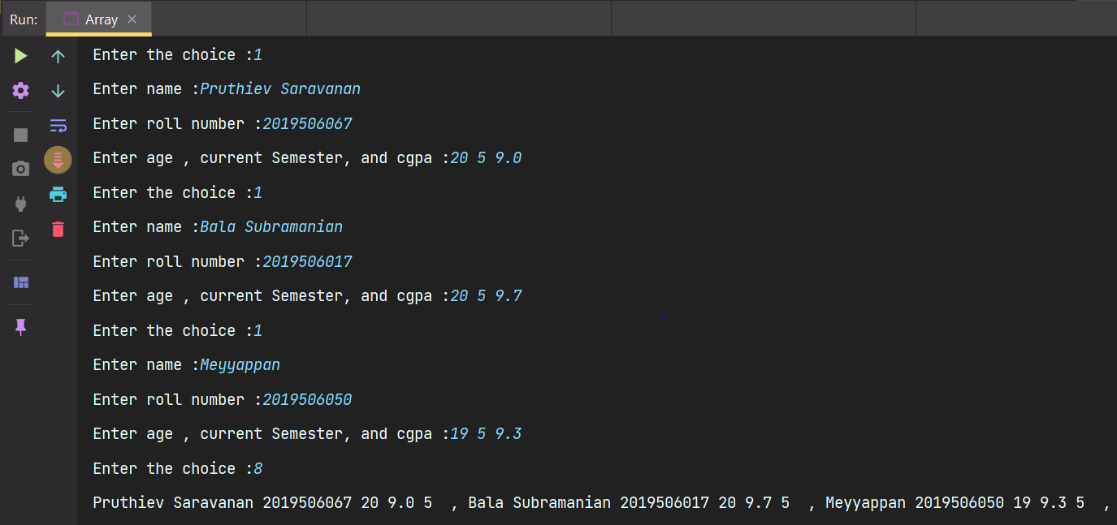

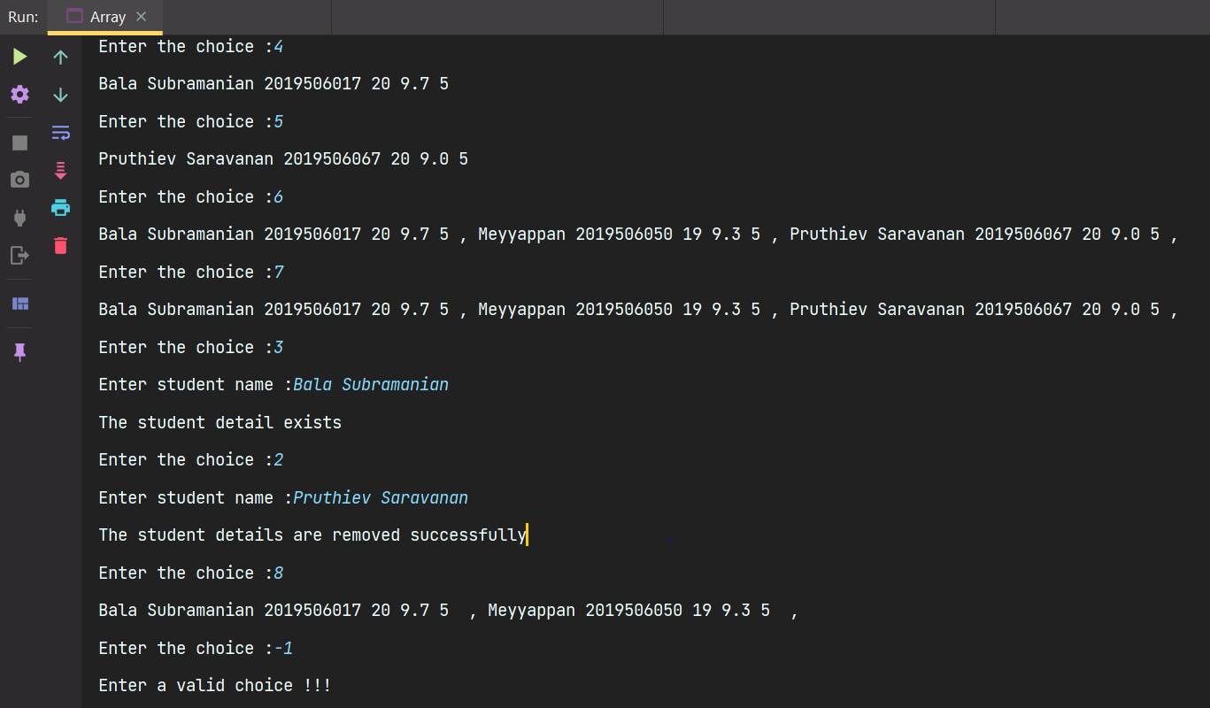

RESULT:
Thus, the program has been executed successfully.
LIST (Collection Library) vs Array(Data type)

LIST | ARRAY
- A list is an interface that extends from collection interface  - It can only store homogeneous elements at any instant of time  - No need of specifying the size before it can resize and add elements dynamically  - It has in-built methods like add , remove,search,isEmpty etc.  - Since it is interface the memory is allocated on heap.  - It can only store non-primitives  - We can traverse the array using ,forEach and iterator as List provide the support of iterators as they implemt the iterable interface.  - We can convert the List to array using toArray methods defined in the Collections class.  - We can perform in-built operations using the interface as well as using the Collections class.  - The syntax and data type to be mentioned is  List<DataType>l = new ArrayList<>(); | - An array is a in-built data type which extends from Object class  - It too can only store homogeneous collection of elements  - The size of the array has to be specified before adding elements to it.  - No built in menthods as such each and everything has to implemented by the programmer who uses array  - Since it is a class it is allocated in heap  - It can store both primitive anhd non primitive data types  - We can traverse using for and enchaned for loop as ther is no support for iterators  - We can convert array to List using Arrays.asList() method defined in the Arrays class.  - We can perform in-built operations only using Arrays class.  - The syntax and data type to mentioned is as follows  DataType arr[] = new DataType[size];

